# Department of Computing

**CS-213: Advanced Programming**

**Class: BSCS 7AB**

# Lab 06: Node.js MongoDB

**Date: 3rd October, 2019**

**Time: 10:00-01:00pm & 02:00-05:00pm**

# Instructor: Dr. Sidra Sultana

**Lab Engineer: Ms. Ayesha Asif**

# 

# Lab 06: Node.js MongoDB

**Introduction**

Node.js can be used in database applications. One of the most popular NoSQL database is MongoDB.

**Objectives**

This lab will get you familiar with the node.js MongoDB environment.

**Tools/Software Requirement**

Node.js, Notepad

**Description**

To be able to experiment with the code examples, you will need access to a MongoDB database.

You can download a free MongoDB database at [https://www.mongodb.com](https://www.mongodb.com/)**Install MongoDB Driver**

Let us try to access a MongoDB database with Node.js.

To download and install the official MongoDB driver, open the Command Terminal and execute the following:

Download and install mongodb package:

C:\Users*Your Name*>npm install mongodb

Now you have downloaded and installed a mongodb database driver.

Node.js can use this module to manipulate MongoDB databases:

var mongo = require('mongodb');

**Helping Material**

Slides of Lecture 7

<https://www.w3schools.com/nodejs/nodejs_mongodb.asp>

**Lab Tasks**

**Task 1:** Create a database named "mydb". Save the code in a file called "demo_create_mongo_db.js" and run the file.

var MongoClient = require('mongodb').MongoClient;

var url = "mongodb://localhost:27017/mydb";

MongoClient.connect(url, function(err, db) {

if (err) throw err;

console.log("Database created!");

db.close();

});

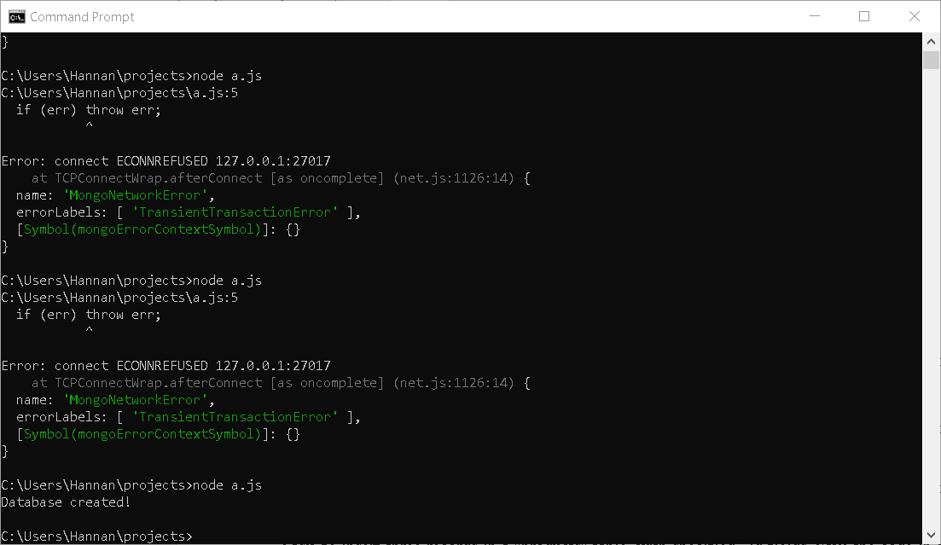

**Task 2:** Create a collection called "customers". Save the code in a file called "demo_mongodb_createcollection.js" and run the file.

var MongoClient = require('mongodb').MongoClient;  
var url = "mongodb://localhost:27017/";  
  
MongoClient.connect(url, function(err, db) {  
  if (err) throw err;  
  var dbo = db.db("mydb");  
  dbo.createCollection("customers", function(err, res) {  
    if (err) throw err;  
    console.log("Collection created!");  
    db.close();  
  });  
});

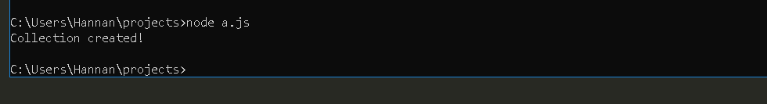

**Task 3:** Insert a document in the "customers" collection. Save the code in a file called "demo_mongodb_insert.js" and run the file.

var MongoClient = require('mongodb').MongoClient;

var url = "mongodb://localhost:27017/mydb";

MongoClient.connect(url,{ useNewUrlParser: true, useUnifiedTopology: true }, function(err, db) {

if (err) throw err;

var dbo = db.db("mydb");

var myobj = { name: "Company Inc", address: "Highway 37" };

dbo.collection("customers").insertOne(myobj, function(err, res) {

if (err) throw err;

console.log("1 document inserted");

db.close();

});

});

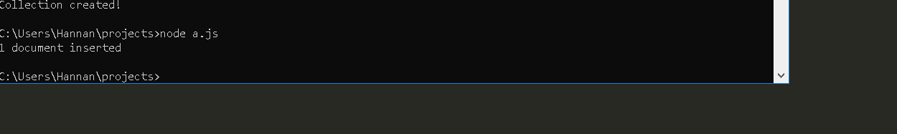

**Task 4:** Insert multiple documents in the "customers" collection. Save the code in a file called "demo_mongodb_insert_multiple.js" and run the file.

**var MongoClient = require('mongodb').MongoClient;**

**var url = "mongodb://localhost:27017/mydb";**

**MongoClient.connect(url,{ useNewUrlParser: true, useUnifiedTopology: true }, function(err, db) {**

**if (err) throw err;**

**var dbo = db.db("mydb");**

**var myobj = [**

**{ name: 'John', address: 'Highway 71'},**

**{ name: 'Peter', address: 'Lowstreet 4'},**

**{ name: 'Amy', address: 'Apple st 652'},**

**{ name: 'Hannah', address: 'Mountain 21'},**

**{ name: 'Michael', address: 'Valley 345'},**

**{ name: 'Sandy', address: 'Ocean blvd 2'},**

**{ name: 'Betty', address: 'Green Grass 1'},**

**{ name: 'Richard', address: 'Sky st 331'},**

**{ name: 'Susan', address: 'One way 98'},**

**{ name: 'Vicky', address: 'Yellow Garden 2'},**

**{ name: 'Ben', address: 'Park Lane 38'},**

**{ name: 'William', address: 'Central st 954'},**

**{ name: 'Chuck', address: 'Main Road 989'},**

**{ name: 'Viola', address: 'Sideway 1633'}**

**];**

**dbo.collection("customers").insertMany(myobj, function(err, res) {**

**if (err) throw err;**

**console.log("Number of documents inserted: " + res.insertedCount);**

**db.close();**

**});**

**});**

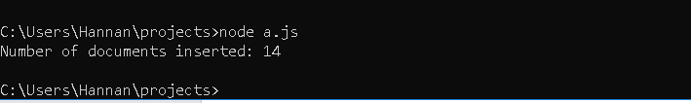

**Task 5:** Insert three records in a "products" table, with specified _id fields. Save the code in a file called "demo_mongodb_insert_id.js" and run the file.

var MongoClient = require('mongodb').MongoClient;

var url = "mongodb://localhost:27017/mydb";

MongoClient.connect(url,{ useNewUrlParser: true, useUnifiedTopology: true }, function(err, db) {

if (err) throw err;

var dbo = db.db("mydb");

var myobj = [

{ _id: 154, name: 'Chocolate Heaven'},

{ _id: 155, name: 'Tasty Lemon'},

{ _id: 156, name: 'Vanilla Dream'}

];

dbo.collection("products").insertMany(myobj, function(err, res) {

if (err) throw err;

console.log(res);

db.close();

});

});

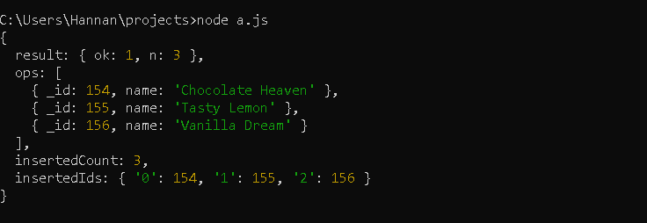

**Task 6:** Find the first document in the customer’s collection. Save the code in a file called "demo_mongodb_findone.js" and run the file.

var MongoClient = require('mongodb').MongoClient;

var url = "mongodb://localhost:27017/";

MongoClient.connect(url, function(err, db) {

if (err) throw err;

var dbo = db.db("mydb");

dbo.collection("customers").findOne({}, function(err, result) {

if (err) throw err;

console.log(result);

db.close();

});

});



**Task 7:** Return the fields "name" and "address" of all documents in the customers collection.

var MongoClient = require('mongodb').MongoClient;

var url = "mongodb://localhost:27017/";

MongoClient.connect(url, function(err, db) {

if (err) throw err;

var dbo = db.db("mydb");

dbo.collection("customers").find({}, { projection: { _id: 0, name: 1, address: 1 } }).toArray(function(err, result) {

if (err) throw err;

console.log(result);

db.close();

});

});

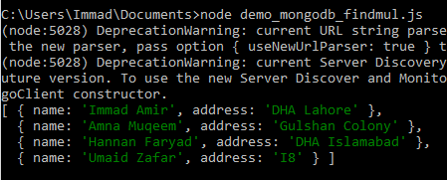

**Task 8:** Find documents with the address "Park Lane 38". Save the code in a file called "demo_mongodb_query.js" and run the file.

var MongoClient = require('mongodb').MongoClient;

var url = "mongodb://localhost:27017/";

MongoClient.connect(url, function(err, db) {

if (err) throw err;

var dbo = db.db("mydb");

var findq = { address: "Gulshan Colony" };

dbo.collection("customers").find(findq).toArray(function(err, result) {

if (err) throw err;

console.log(result);

db.close();

});

});

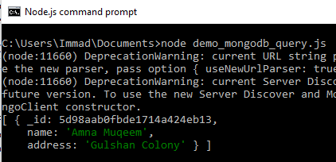

**Task 9:** Sort the result alphabetically by name. Save the code in a file called "demo_sort.js" and run the file.

var MongoClient = require('mongodb').MongoClient;

var url = "mongodb://localhost:27017/";

MongoClient.connect(url, function(err, db) {

if (err) throw err;

var dbo = db.db("mydb");

var namesort = { name: 1 };

dbo.collection("customers").find().sort(namesort).toArray(function(err, result) {

if (err) throw err;

console.log(result);

db.close();

});

});

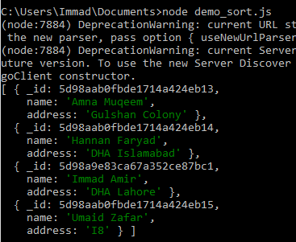

**Task 10:** Delete the document with the address "Mountain 21". Save the code in a file called "demo_delete.js" and run the file.

var MongoClient = require('mongodb').MongoClient;

var url = "mongodb://localhost:27017/";

MongoClient.connect(url, function(err, db) {

if (err) throw err;

var dbo = db.db("mydb");

var deleteq = { address: 'DHA Islamabad' };

dbo.collection("customers").deleteOne(deleteq, function(err, obj) {

if (err) throw err;

console.log("Document deleted.");

db.close();

});

});

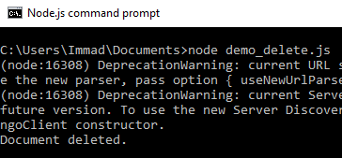

**Task 11:** Delete all documents were the address starts with the letter "O". Save the code in a file called "demo_delete_many.js" and run the file.

var MongoClient = require('mongodb').MongoClient;

var url = "mongodb://localhost:27017/";

MongoClient.connect(url, function(err, db) {

if (err) throw err;

var dbo = db.db("mydb");

var delq = { address: /^D/ };

dbo.collection("customers").deleteMany(delq, function(err, obj) {

if (err) throw err;

console.log(obj.result.n + " documents deleted");

db.close();

});

});

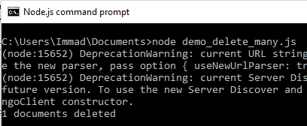

**Task 12:** Delete the "customers" table. Save the code in a file called "demo_drop.js" and run the file.

var MongoClient = require('mongodb').MongoClient;

var url = "mongodb://localhost:27017/";

MongoClient.connect(url, function(err, db) {

if (err) throw err;

var dbo = db.db("mydb");

dbo.collection("customers").drop(function(err, del) {

if (err) throw err;

if (del) console.log("Collection deleted.");

db.close();

});

});

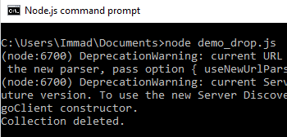

**Task 13:** Update the document with the address "Valley 345" to name="Mickey" and address="Canyon 123". Save the code in a file called "demo_update_one.js" and run the file.

var MongoClient = require('mongodb').MongoClient;

var url = "mongodb://127.0.0.1:27017/";

MongoClient.connect(url, function(err, db) {

if (err) throw err;

var dbo = db.db("mydb");

var uquery = { address: "I8" };

var val = { $set: {name: "Sabayna Ali", address: "G11" } };

dbo.collection("customers").updateOne(uquery, val, function(err, result) {

if (err) throw err;

console.log("Document updated.");

db.close();

});

});

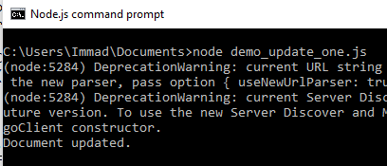

**Task 14:** Consider you have a "customers" collection. Limit the result to only return 5 documents. Save the code above in a file called "demo_mongodb_limit.js" and run the file.

var MongoClient = require('mongodb').MongoClient;

var url = "mongodb://localhost:27017/";

MongoClient.connect(url, function(err, db) {

if (err) throw err;

var dbo = db.db("mydb");

dbo.collection("customers").find().limit(5).toArray(function(err, result) {

if (err) throw err;

console.log(result);

db.close();

});

});

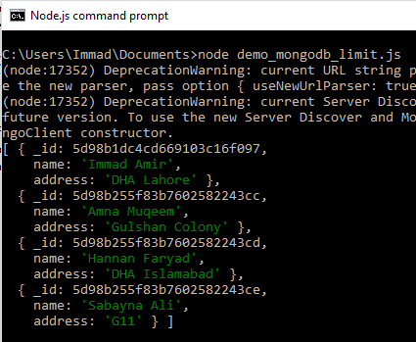

**Task 15:** Practice the Join operations on different tables.

var MongoClient = require('mongodb').MongoClient;

var url = "mongodb://127.0.0.1:27017/";

MongoClient.connect(url, function(err, db) {

if (err) throw err;

var dbo = db.db("mydb");

dbo.collection('customer').aggregate([

{ $lookup:

{

from: 'products',

localField: '_id',

foreignField: '_id',

as: 'productbought'

}

}

]).toArray(function(err, result) {

if (err) throw err;

console.log(JSON.stringify(result));

db.close();

});

});

